Agentic AI Middleware: Architecture Flow, Rationale and Decisions

Purpose and status
This note walks through the v3 architecture diagram: how a lead event travels through the middleware, why each component exists, and which decisions are still open before implementation starts.
The diagram responds to two pieces of supervisor feedback: every part of the architecture should be autonomous, and every artifact must be explained. Compared with the proposal's Figure 3.2, Agent 4 is now a module (M1), the agents are renumbered 1 to 5, a scheduler wakes the system on a timer, and the orchestrator is a supervisor agent that decides which agents run.
How to read the diagram
- Blue boxes are autonomous components: they perceive, reason through the LLM, and act.
- Gray boxes are deterministic components: no reasoning, fixed behaviour.
- Dashed boxes are future or optional and sit outside the proof of concept.
- Numbered circles are the flow steps explained below.

Architecture diagram
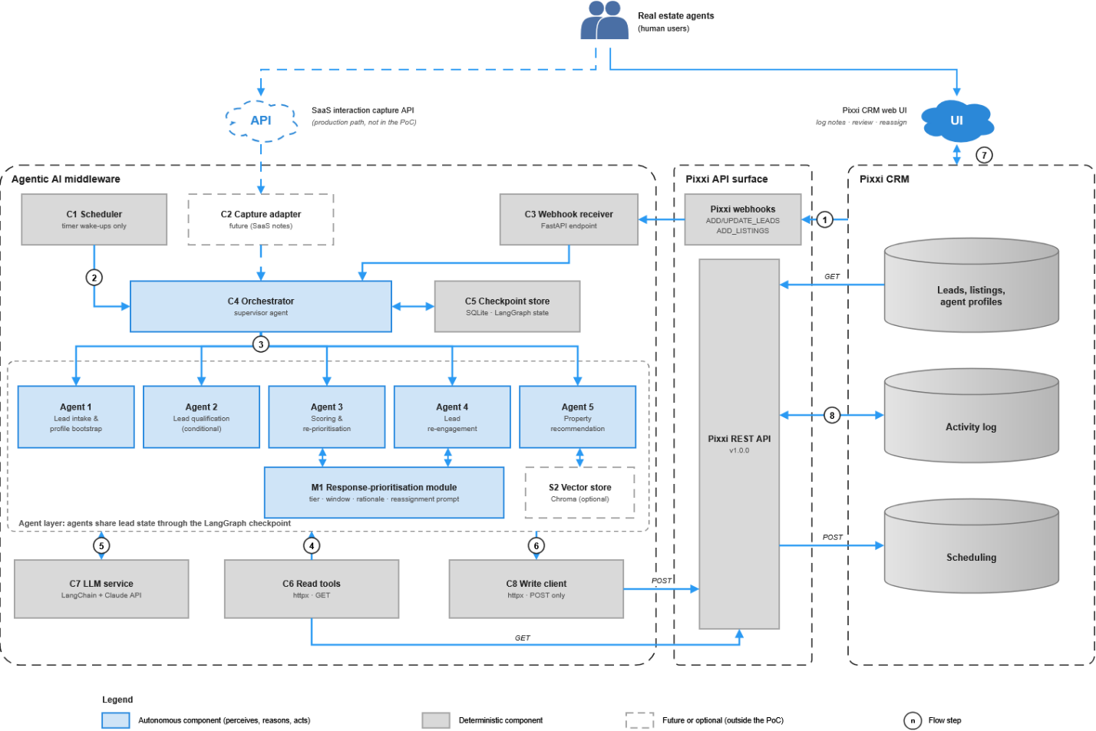
Figure: Agentic AI middleware architecture (autonomy-revised), technical component reference.

Flow of the diagram
A lead event enters through a webhook or the scheduler, the orchestrator chooses which agents act, the agents read, reason and write, and outcomes are read back so the system can correct itself. Each step matches a numbered circle in the figure.
Step | What happens | Why it is designed this way
1 | Pixxi fires a webhook (ADD_LEADS, UPDATE_LEADS or ADD_LISTINGS) to the Webhook receiver (C3). | Pixxi's public webhooks are the only event source, so the middleware needs no change to the CRM. C3 also drops events caused by the system's own writes, to avoid loops.
2 | The Scheduler (C1) wakes the Orchestrator (C4) on a timer. | Some work has no event: a dormant lead produces no webhook, and a reminder that was ignored produces none either. A timer is the only trigger for these.
3 | The Orchestrator decides which agents to run and in what order, and saves its state in the Checkpoint store (C5). | A fixed router repeats the "logic sequence" weakness; a supervisor chooses based on the lead's state. Code still enforces hard rules, such as Layer 2 data being required for forward matching.
4 | Agents perceive: they choose which Pixxi GET calls to make through the Read tools (C6). | Choosing what to look at is part of autonomy. All reads are GET because that is what the API offers on lead records.
5 | Agents reason through the LLM service (C7). Agents 3 and 4 also call the Response-prioritisation module (M1). | One shared LLM service keeps prompts, models and outputs consistent and makes cost and logging easy to track.
6 | Agents act: structured outputs leave only through the Write client (C8), as POST /activities and POST /reminder. | Pixxi has no PUT or PATCH on lead records (confirmed), so one POST-only exit point is both a constraint and an audit point. Every write carries the agent ID and a written rationale.
7 | Real estate agents log notes, review suggestions and decide in the Pixxi UI. Ownership changes happen only there. | Agents are autonomous in deciding, not in executing. This matches the human-oversight and PDPL commitments in Section 3.18.
8 | Agents read /activities back to see what happened. | Without PUT or PATCH, this read-back is the only way to close the loop and re-plan, for example when a reminder was ignored.

Components
There are five agents, one orchestrator and one module that reason; everything else is deterministic infrastructure.
ID | Component | Type | Role | Rationale
C1 | Scheduler | Deterministic | Timer wake-ups for dormancy sweeps and reminder-outcome checks. | Covers work that no webhook can trigger. It only wakes the orchestrator; the reasoning happens there.
C2 | Capture adapter | Future | Receives private post-call notes from the SaaS capture app. | Production path from Section 3.15. In the PoC, notes arrive through the Activity Log instead.
C3 | Webhook receiver (FastAPI) | Deterministic | Receives Pixxi events, de-duplicates them, ignores events caused by the system's own writes. | Pixxi needs an HTTP endpoint to call. FastAPI fits the Python 3.11 stack; Flask would also work.
C4 | Orchestrator | Autonomous | Supervisor agent: decides which agents run and in what order, re-plans from outcomes. | Fixed conditional routing is rule-based. Code-enforced preconditions keep safety rules reliable.
C5 | Checkpoint store (SQLite) | Deterministic | Persists LangGraph state so work can pause and resume. | Long-running decisions must survive restarts and be auditable.
A1 | Agent 1: lead intake and profile bootstrap | Autonomous | Builds a Layer 1 profile from the portal fields and the referenced listing, then prompts the agent to log details. | Gives value from the moment a lead enters the CRM, with no human input.
A2 | Agent 2: lead qualification (conditional) | Autonomous | Extracts confirmed intent, budget, timeline and financing from logged notes. | Only runs when notes exist; the others work without it.
A3 | Agent 3: scoring and re-prioritisation | Autonomous | Scores leads from Layer 1 data, then re-scores from the confirmed profile. Calls M1 for priority and timing. | Weights Layer 2 above Layer 1. Excludes demographic attributes from scoring.
A4 | Agent 4: lead re-engagement | Autonomous | Finds dormant leads and drafts a personalised message for the real estate agent to send. | Drafts only, never sends, for PDPL compliance. Calls M1 for timing.
A5 | Agent 5: property recommendation | Autonomous | Forward match (confirmed profile against listings) and reverse match (new listing against leads). | The ±10% budget tolerance in Section 3.12 is algorithmic; the LLM would add ranking and rationale.
M1 | Response-prioritisation module | Autonomous | Takes score, enquiry source, agent workload and recency; returns priority tier, contact window, rationale and a reassignment prompt. | The old Agent 4 logic as a callable service with no goal loop of its own. It never writes to Pixxi.
S2 | Vector store (Chroma) | Optional | Stores listing descriptions as embeddings so Agent 5 could match by meaning. | Not in the proposal. Only useful for free-text preferences. Decision D5.
C6 | Read tools | Deterministic | GET calls: /lead/list, /properties, agent profiles, /activities. | Agents choose which to call.
C7 | LLM service (LangChain + Claude) | Deterministic | Prompt template, model call and structured output for every autonomous component. | One shared service gives consistent logging and cost tracking.
C8 | Write client | Deterministic | POST-only: /activities and /reminder, tagged with agent ID and rationale. | Single exit point; reflects the confirmed API constraint.

Design reasoning
Four design choices differ from the proposal.
Agent 4 becomes module M1. The original Agent 4 used fixed rules, and the redesign note replaced them with reasoning over four signals. As a module, it is a reasoning service called by Agent 3 and Agent 4, which removes the overlap between "scoring and re-prioritisation" and "response prioritisation". The cost is that O5, the abstract and Table 3.3 must change, and RQ3's timing evaluation should compare results with and without M1.
Proposal numbering | New numbering
Agent 1: lead intake | Agent 1
Agent 2: lead qualification | Agent 2
Agent 3: scoring and re-prioritisation | Agent 3 (now calls M1 for timing)
Agent 4: lead response timing | Module M1
Agent 5: lead re-engagement | Agent 4
Agent 6: property recommendation | Agent 5
Agent 7: orchestration agent | Orchestrator (C4)
The orchestrator is a supervisor, not a router. LangGraph stays; what changes is who picks the next step. A conditional edge is a fixed if/else on layer classification, which is the same rule-based pattern. A supervisor LLM chooses the next agent from the lead's state, while code enforces the facts that are not judgments: Agent 2 needs notes, forward matching needs Layer 2, nothing is sent automatically, and no lead field is ever overwritten.
Dormancy needs a scheduler. A lead is dormant when no activity or reminder occurs for 30 days. Webhooks fire when something changes, so a dormant lead never triggers one. Table 3.3's "UPDATE_LEADS" trigger for the re-engagement agent therefore cannot work; the scheduler wakes the orchestrator, which runs Agent 4 over GET /lead/list. Re-engagement matters because it is mentioned that many unconverted leads buy later if re-engaged on time and personally.
Autonomy is separated from authority. Agents decide and recommend; only a human executes ownership changes, in the Pixxi UI. This is forced by the missing PUT and PATCH endpoints, and it matches the human-oversight and PDPL commitments already in the proposal.

Inconsistencies to fix before implementation
Nine problems in the proposal or earlier diagram would cause bugs or contradictions if left as they are.
# | Issue | Why it matters | Fix
1 | Re-engagement trigger is listed as UPDATE_LEADS in Table 3.3 but Section 3.13 describes a scheduled scan. | A dormant lead produces no event, so the agent would never run. | Use the scheduler; update Table 3.3.
2 | The orchestrator's trigger is "all webhook events". | It also needs timer triggers. | Add scheduler wake-ups to the Table 3.3 row.
3 | The system's own notes and reminders may update a lead's updateTime. | No lead would ever count as dormant. | Tag every write with an AI marker and ignore it when measuring dormancy.
4 | POST /activities or POST /reminder may fire UPDATE_LEADS webhooks. | Possible infinite loop: agent writes, webhook fires, agent runs again. | Test against the API; C3 filters events caused by the system's own writes.
5 | The earlier diagram shows Chroma and RAG; the proposal's Section 3.12 describes a tolerance-band algorithm. | Diagram and text describe different systems. | Decide D5.
6 | Section 3.16 says the orchestrator is a StateGraph with conditional edges. | Contradicts the supervisor design. | Rewrite Section 3.16.
7 | The time-to-first-contact metric assumes humans respond to reminders, but the data is synthetic and the system cannot contact leads. | The metric cannot be measured as written. | Measure the recommended contact window against the baseline instead.
8 | "Layer 1/2" means data layers in the proposal, and Figure 3.2 also uses "Layer 1 to 4" for architecture levels. | The same word has two meanings. | Call architecture levels "tiers".
9 | The proposal says "Claude or GPT-4"; the diagram says Claude. | The model must be fixed before implementation. | Choose one for the PoC.

Questions and decisions
Three decisions are still open (D3, D4, D5), and four questions need to be fixed before implementation starts.
Decisions
ID | Decision | Options | Default in the diagram | Status
D1 | Agent 4 as a module | Module (M1) or keep as an agent with a feedback loop | Module | Settled
D2 | Agent numbering | Renumber 1 to 5, or keep old numbers with a gap | Renumber | Settled
D3 | Orchestrator autonomy | Hybrid: LLM chooses, code enforces rules. Or fully LLM-driven. | Hybrid. Rules such as Layer 2 prerequisites and no automatic sending are facts, so code guarantees them and they can be audited. Fully LLM-driven is the strongest autonomy claim but is harder to reproduce across the 100-lead evaluation, and you cannot tell an agent mistake from a missing guardrail. | Open
D4 | Scheduler | Plain timer that only wakes the orchestrator, or a reasoning monitor that picks which leads need attention | Plain timer. It is cheap and testable, and the orchestrator already reasons. A reasoning monitor adds a second reasoner and more LLM cost. | Open
D5 | Vector store (S2) | Keep as optional, remove, or adopt and rewrite Section 3.12 | Kept as dashed and optional. It stores listing descriptions as embeddings so Agent 5 can match by meaning; it only helps with free-text preferences. | Open
D6 | Second flagged agent | Keep as an agent | Kept; not yet identified | Settled for now

Questions :
- Is a supervisor LLM with code-enforced rules acceptable as "autonomous", or must routing itself be fully LLM-driven?
- Is a response-prioritisation module acceptable in place of an agent, given that it reasons but has no goal loop of its own?
- Is it acceptable that agents decide and recommend while a human executes ownership changes, because Pixxi offers no PUT or PATCH?
- Can the timing metric be changed to compare the recommended contact window with the baseline, since the data is synthetic and the system cannot contact leads?

